**Event Description**

AUDM will be hosting their first ever silent disco in the AU Hotel Ballroom! Tickets are $10 and will feature Sky Bars resident DJ, Ben Bruud. The theme is Disney to correlate with AUDM’s mission of providing fundraising for Children’s Miracle Network Hospitals.

**Budget**

Headphones: $425. We will be renting the headphones from partyheadphones.com. They are an online party rental company that will provide us with quality light up headphones for a rather low cost.

DJ: $200. DJ Mark has volunteered to perform pro-bono. He is an Auburn Alumni who took part in many AUDM events during his time at Auburn. Because he is doing this out of the good of his heart we want to make sure that we tip him well for his services. We determined that $200 would be sufficient for the event.

Decor: $100. We want to keep it affordable and simple. We decided to go with party balloons and streamers to spice up the room a little. We also rented a fog machine and some laser lights to add some visual effects to the disco.

Venue: The Auburn Hotel has kindly rented us their ballroom free of charge. They love AUDM’s cause and said that hosting the event alone would be enough payment. As with the caters we will be advertising for The Auburn Hotel on social media and during the event.

Advertising: $275; $125 for social media ads; $150 for shirts/flyers/posters. We will be spending $125 of it on paid social media advertising. We want to ensure that our message is put in front of the eyes of our audience so we will be paying for premium advertising on specific platforms like Instagram and Tik Tok. The remaining $150 will be spent on making the event t-shirts, flyers, and posters.

**Contacts**

**Function:**  Auburn University Dance Marathon Presents a Silent Disco fundraiser

Date: October 14, 2022

**Venue:**  The Hotel at Auburn University and Conference Center ballroom, 241 South College Street, Auburn, Alabama 36830

Contact name: Tina Lyles (event manager @ the hotel) ………………………………………………………………………………………………….

Tel: (334) 821-8200 ………………………………………………………………………………………………….

email: tinalyles@auhcc.com ………………………………………………………………………………………………….

**Caterer:**  Gutherie's ………………………………………………………………………………………………….

Contact Name: Joe Kelly Guthrie (CEO) he deals with all sponsored events ………………………………………………………………………………………………….

Tel: (334) 209-2233 ………………………………………………………………………………………………….

email: guthrieschickenfingers@gmail.com ………………………………………………………………………………………………….

**Musicians:**  DJ ………………………………………………………………………………………………….

Contact Name: Ben Bruud ………………………………………………………………………………………………….

Tel: (256) 558-4984 ………………………………………………………………………………………………….

email: benbruud78@gmail.com ………………………………………………………………………………………………….

**Other Suppliers:** Party Headphones (headphone rentals) ………………………………………………………………………………………………….

Contact Name: Leslie Franks ………………………………………………………………………………………………….

Tel: (833) 727- 8947 ………………………………………………………………………………………………….

email: leslief@partyheadphones.com ………………………………………………………………………………………………….

Other: $425 to rent 200 headphones and the rental kit ………………………………………………………………………………………………….

**Checklist**

**Purpose:**  The purpose of this event is to raise money for AUDM’s children’s miracle Network Hospital in Columbus, Ga.,

**Guests:**  Members of AUDM, children that are sponsored by AUDM, and Auburn students interested in what AUDM does

**Number:**  200 guests are invited, this includes AUDM members and a plus one, they must RSVP a week in advance

**Style:**  Casual, informal event. Dress comfortably

**Venue:**  The Hotel at Auburn University and Conference Center ballroom.

**Food:**  We have partnered with a local restaurant that is native to Auburn and they are supplying the food pro-bono. In order to give some form of payment to the caters we will be advertising their brands throughout the event. Online when posting reminders about the event we will add that Gutherie’s is providing the food free of charge. At the event we will also allow for Gutherie’s to mount a few banners on the walls of the room and decorate some of the food displays with their brand name.Complimentary catering chicken fingers and fries + sauces.

**Drinks:**  Lemonade, tea, and water complimentary of Gutheries

**Music:**  DJ Ben Bruud (At no cost/volunteered). Arrives at 7pm to set up, begins playing at 7:50pm, his break will be 8:45-9:00pm, plays until 10:00pm, takedown should take about 30-45 minutes.

**Furniture:**  Tables, table covers, and chairs will be provided by AU Hotel.

**Décor:**  Balloons and streamers that create a “disco” vibe. AUDM members that are hospitality majors are in charge of decorating.

**Budget:**  $1000 (refer to page 1 for a break down of how we plan to use the budget)

**Staffing:**  Local volunteers, members of AUDM.

**Security:**  Hotel Security provided by the Auburn Hotel, 24 hr surveillance, and security camera at every entrance and exit of the hotel.

**Transport:** Uber/lyft, walking distance from on-campus dorms

**Parking:**  The hotel has a valet service for those who drive, the parking deck to the right of the hotel is also an option.

**Cleaning:**  AUDM members will stay afterwards for clean-up. This should take about an hour so everyone will be out of there by 11:00pm.

**Other:**  Non-smoking event

**News Release**

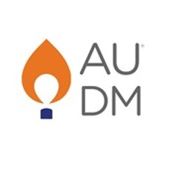

255 Heisman Drive Suite 3130

Auburn, AL 36849

[www.audm.aubuurn.edu]

**______________________________________________________________________**

Media Contact: Anna Snead, (334)-789-0445

ars0116@A&UStrategies.com

For immediate Release:

Oct. 3, 2022

**AUDM: Silent Disco Event**

AUBURN, AL (Oct.3, 2022) – Auburn University Dance Marathon (AUDM) is scheduled to have the first annual Silent Disco event on October 14, 2022, 8-10 PM. The venue location will be at The Hotel at Auburn University and Conference Center ballroom.

The event theme is Disney to correlate with AUDM’s mission of providing funds for Children’s Hospitals. Pricing of tickets will start at $10 and will be featuring Sky Bar resident, DJ Ben Bruud for event entertainment.

The organization will provide food and drinks from Gutherie's.

AUDM members are invited and welcome to bring one guest to the event.

For more information on AUDM Silent Disco, including tickets & additional information, visit  [www.audm.auburn.edu](http://www.audm.auburn.edu)

The two media sources we will pitch to: Auburn Plainsman and Auburn Network Inc.

**Social media Post**

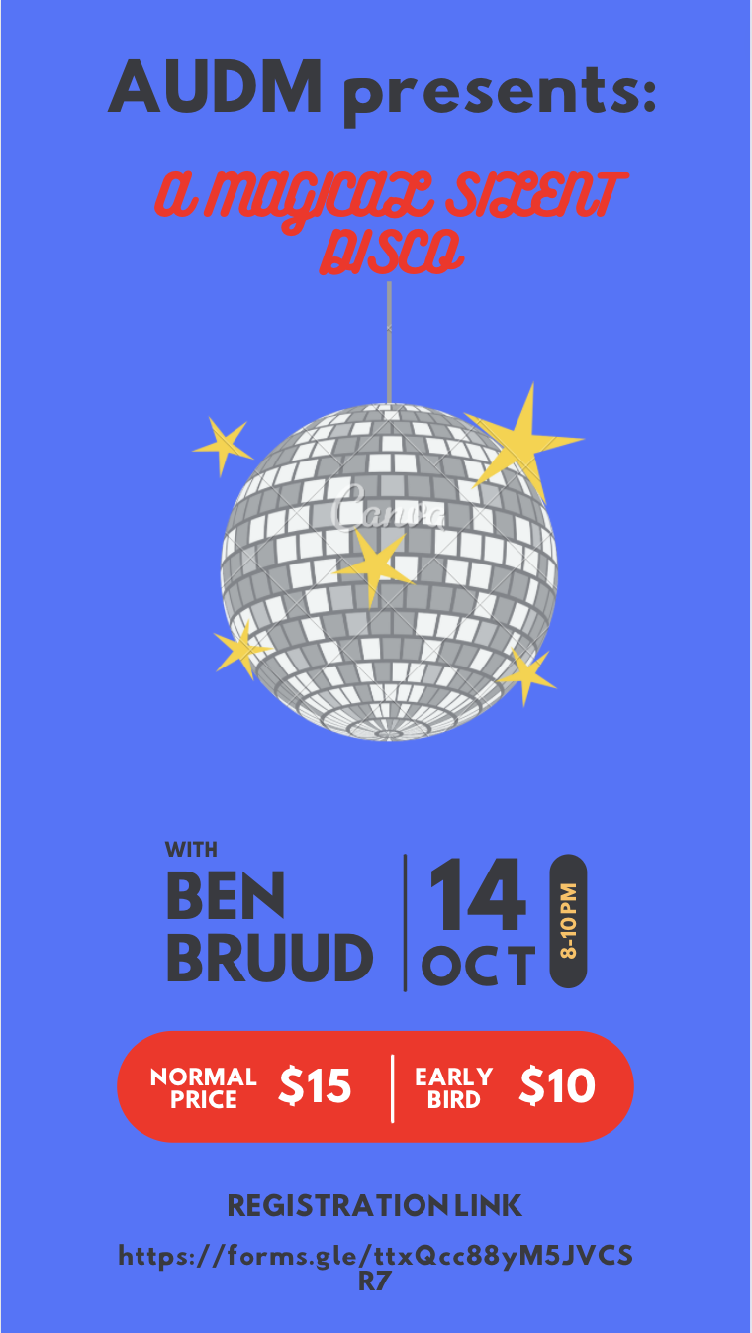

The social media post will be shared via AUDM’s Instagram, Facebook, and posted on their website under upcoming events. On instagram it will be posted 2 months in advance so on August 14th the fundraiser announcement will be announced with this post. The caption will be all other details and a way to get involved or volunteer at it and a link to purchase a ticket at the early bird price. Up until the event, AUDM must regularly remind their audience on social media about the event and encourage them to tag their friends in the comments.