Logo/color scheme

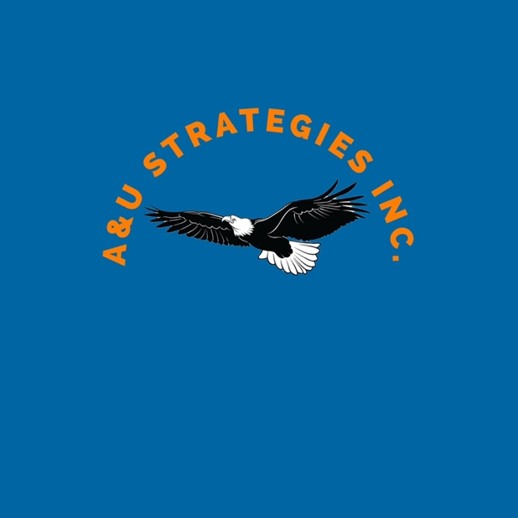
Our agency chose blue (HEX #0C2340) and orange (HEX #E87722for our website and logo because we want to represent the Auburn community and serve Auburn based organizations. Auburn’s rich culture drew our team members to Auburn University four years ago and we intend to resonate the same values through our business. We chose the font ‘Agency’ to present a minimalist yet professional and smart appearance. We hope that the simplicity of our font and color scheme appeals to our audience’s eyes and draws them into our work. We chose to go with the same color scheme for our logo as well. Since Auburn is a big part of our team members and customers lives, we decided to incorporate our name with one of Auburn University’s mascots, the bald eagle.

Website Link

https://erm0047.wixsite.com/website

